**USER STORY**

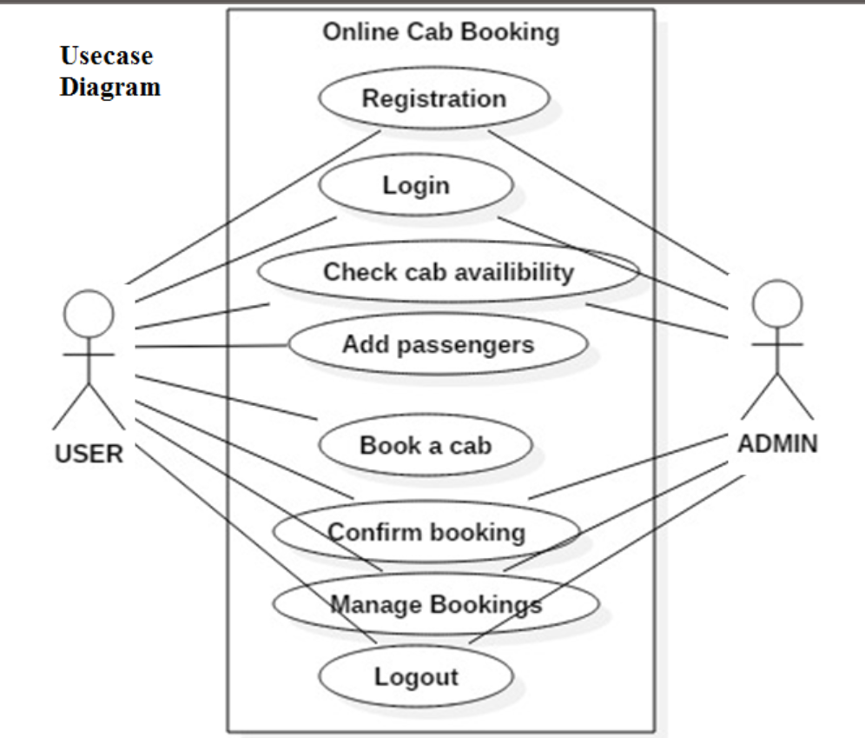

**User Registration:**

As a new user I can able to register the account in cab booking system using my mail Id and phone number.

The system should verify my mail Id and phone number through OTP verification.

**Login :**

As a user, I want the option to log in using either my registered email or phone number.

**Forgot Password :**

As a user I can forgot the password sometimes ,So if I forgot the password, I want a simple process to reset my password through SMS.

**Check Cab Availability :**

As a user I can check availability of the cab between pickup and drop location, So that I can see the availability of the cabs.

**Cab booking:**

As a user I want a simple interface to enter my pickup and drop location. So that the system should provide information about the available cabs nearby.

**Cab Selection and Details:**

As a user, I want to view the details of available cabs, including driver information, cab type and estimated time arrival.

The system should display the fare estimation before confirming the booking.

**Confirm Booking:**

As a user I want to receive an confirmation with details like cab number, driver name , and contact information. The system should be able to give the update’s on cab location.

**Manage Bookings:**

**Active Bookings:**

As a user**,** I want to see a list of my active bookings, So that I can able to see the booking date, time pickup, drop location and type of the cab.

**Cancel Booking:**

As a user, I want the option to cancel a booking if my plans change. The system should allow me to cancel a booking before the deadline.

**Logout:**

As a user, I expect to find a "Logout" button prominently displayed in the user interface, accessible within the account settings or navigation menu.

**Confirmation Prompt:**

As a user, I want the system to confirm my decision to log out to prevent accidental logouts.

The system should display a confirmation prompt asking, "Are you sure you want to log out?" with options to confirm or cancel the action.